**CN vs MCIc – X axis**

**Approach 1**

**Network:**

Transfer learning from AlexNet changing last 3 layers.

|  |  |
| --- | --- |
| **Training parameters:**   * folds=3; * miniBatchSize = 30; * learningRate = 1e-4; * maxEpochs=10; * optimizer='sgdm'; | **Dataset:**   * nSlices=6; * gap=2; |

**Results:**

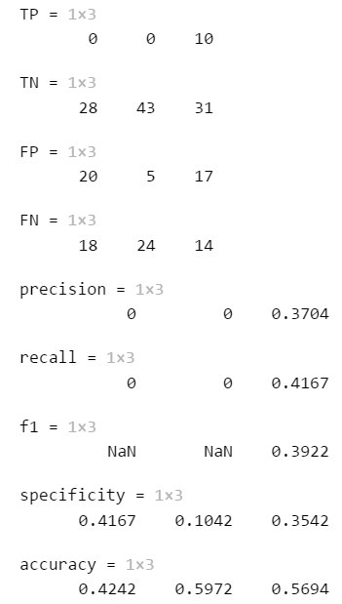

Approach 2 (primo test su pc di Luca con parametric uguali a quelli di Stefano)

|  |  |
| --- | --- |
| **Training parameters:**   * folds=3; * miniBatchSize = 30; * learningRate = 1e-4; * maxEpochs=10; * optimizer='sgdm'; | **Dataset:**   * nSlices=6; * gap=2; |

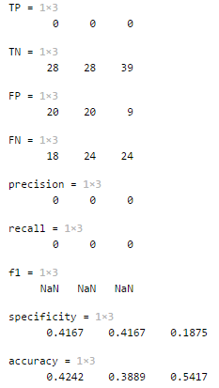

Approach 3 2019_03_31_19_21

|  |  |
| --- | --- |
| **Training parameters:**   * folds=3; * miniBatchSize = 64; * learningRate = 1e-4; * maxEpochs=10; * optimizer='sgdm'; | **Dataset:**   * nSlices=6; * gap=2; |

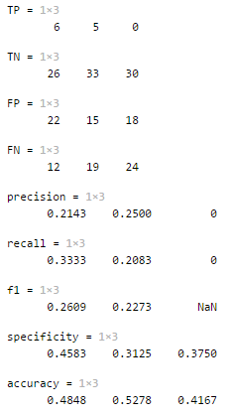

Approach 4 2019_03_31_19_44

|  |  |
| --- | --- |
| **Training parameters:**   * folds=3; * miniBatchSize = 64; * learningRate = 1e-4; * maxEpochs=15; * optimizer='sgdm'; | **Dataset:**   * nSlices=6; * gap=2; |

